Chapter 8
Endophytes

Introduction

Since the existence of endophytes was first noted by Henry Anton De Barry over 150 years ago, there have been various debates about what constitutes a true endophyte (1866). A commonly accepted definition is that of Petrini: “all organisms inhabiting plant organs that, at some point in their life, can colonize internal plant tissues without causing apparent harm to the host” (1991). However, nature is prone to resisting the human compulsion of its classification into parts. Many plant-associated mutualists are close relatives of pathogenic species, with role switching frequently occurring over evolutionary time. Certain microbe-plant associations may even vary from mutualist to pathogen, depending on the context of environmental circumstances within which they occur.
Endophytes are a diverse group of unrelated organisms typified by their ability to reside inside the bodies of apparently healthy host plants. Species among archaea, bacteria, and fungi are all able to live endophytically within plants. Some endophytes are extremely host specific, associating only with a specific plant species or even race of plant species. Whereas others are generalists, capable of living within a diversity of host plant species.
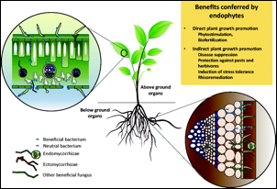
Figure 8.1. Diagram of fungal colonization of various plant parts.

Endophytes occur ubiquitously within nearly all plants and in all regions within a plant body, including inter- and intra-cellularly within roots, stems, barks, leaves, and seeds. Often, different tissue types (leaf, petiole, stem, bark, ect) harbor different groups of specialized symbionts (Fig. 1). This means that a Cannabis plant is nearly always colonized with many different fungal species. Many endophytes specialize in particular tissues of a plant, or may exists systematically throughout the entire plant body. To add to this complexity, fungal endophytes may host intracellular prokaryotic endosymbionts themselves. Furthermore, any of these symbiont layers may host viruses and viroids, and each of these levels have a role in altering the expressed phenotype of the host plant (Márquez et al., 2007).
Endophytic fungi may be transmitted to new host plants vertically (seed borne) or horizontally (environmentally acquired). Seed borne endophytes are usually highly specialized symbionts that form extensive, systemic infections, and are more likely to be host plant species specific (Rodriguez et al. 2008). Common examples of such endophytes are the Claviceptacean endophytes of grasses.
The most famous example of a Claviceptacean endophyte is Claviceps purpurea, known as ergot. Ergot is a source of lysergic acid (LSA) from which LSD was originally synthesized. Interestingly, the related, vertically acquired Claviceptacean epiphyte genus, Periglandula, is responsible for the ergot alkaloid content of seeds of some plants within the Morning Glory family, including Hawaina Baby woodrose (Argyreia nervosa) and Ololiuhqui (Ipomoea corymbosa). Vertically acquired endophytes infect the embryo of the developing seed while it is still attached to its mother plant, or they take refuge on the seed surface and immediately infect the plant when it germinates. Horizontally acquired endophytes, on the other hand, must disperse into the environment in search of new suitable host plants to infect.

Host infection by endophytes

Endophytes passed vertically from parent to offspring may be transported within the bodies of generations of its host without ever being exposed to the external world. However, this occurs on a continuum. While more specialized endophytes may have lost the ability to produce reproductive propagules and spread horizontally among a population of plants, other endophytes may both be vertically transmitted as well as capable of forming spores able to infect new host lineages horizontally. The aforementioned Claviceps purpurea still causes its host grass to abort some seed, replacing it with a fungal sclerotia capable of ascospore production for horizontal dissemination. The grass endophyte Epichloë, on the other hand, has lost the ability to disperse via spores and do not abort their hosts’ seed (Schardl et al. 2004).
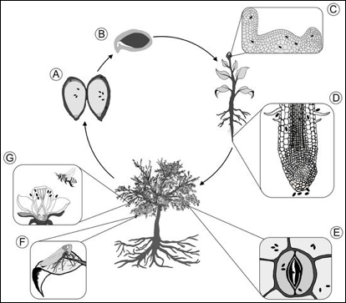
Fig. 8.2 Transmission of endophytic organisms to plant tissue.
Endophytes that spread horizontally require dispersal into the environment, the location of a suitable host, followed by successful infection of that host (Fig 2). Infection of a host necessitates entering its body. Once a fertile propagule lands on a suitable host plant it must first overcome physical defenses innate to any plant. This includes breaking through protective barriers of dead bark tissue, waxy cuticle, and cell wall, which may be accomplished in several ways. Wounded host tissue offers a shortcut for entry when a spore or growing hyphae happens upon it. Alternatively, if a spore lands on healthy plant tissue, fungi must proactively form penetrating structures called appressoria (Fig 3.)

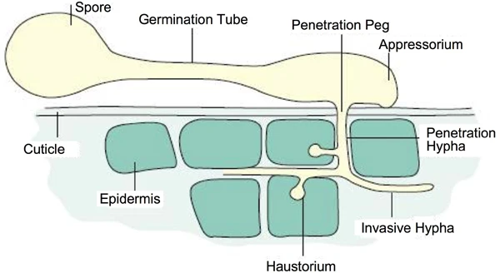
Figure 8.3. Fungal spore germination, emitting a germ tube which gives rise to an appressorium for the fungus to enter into the plant cell and produce a haustorium to acquire nutrients.

An appressorium forms following spore germination or from mature hyphae. Often appressoria develop directly over a natural weak point on the plant surface, such as a stomate or at the juncture of two epidermal cells. Appressoria are specialized hyphal structures which release exoenzymes onto the leaf surface, weakening the physical strength of the cuticle and cell wall below (Fig. 3). At the same time a large amount of turgor pressure builds within the appressorium and is focused on a developing outgrowth of hyphae called the penetration peg. The fungi successfully infects its host if the penetration peg breaks through into the host body and the fungi is able to take up residence. Pathogenic fungi gain entry to the plant body in the same way -and provoke many of the same plant defenses.

Evolution and Ecology

Endophytic associations of fungi within plants began early among, if not coincidentally with, the invasion of land by plants (Krings et al. 2012). Direct fossil evidence showing endophytic fungi has been found, and the coevolution of endophytes and their plant hosts can be inferred from the correlation between the phylogenies of extant endophyte lineages and that of their corresponding plant host taxons (Fig. 3, Krings et al. 2007; Sieber 2007).
The long evolutionary history of specialist endophytes and their hosts generally precludes them from acting as devastating pathogens. However, endophytes exist on a continuum from pathogen to mutualist; many pathogens are closely related to commensal or mutualistic endophytes, with frequent role switching having occurred through evolutionary history (Sieber 2007). The close relation between pathogens and mutualist symbionts is a common feature among plant-microbe interactions. In some cases the switch can be governed by a single gene. Inoculation of susceptible plants with non-pathogenic strains of harmful plant pathogens can even act as biocontrol to prevent plant disease (Punja, 2018).

Cannabis endophytes
Table 1. Characteristics pertaining to the 4 classes of endophytes.
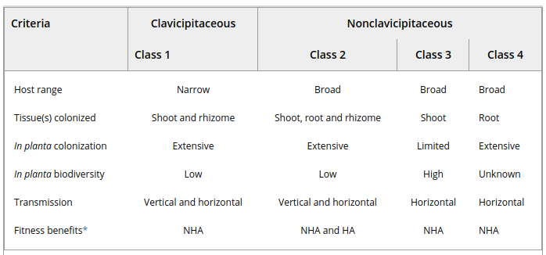

Endophytes of Cannabis are likely dominated by horizontally transmitted, taxonomically diverse endophytic fungi. Various commercially available products include putative Cannabis endophytes, such as arious Trichoderma species or Beauveria bassiana. Some of these are likely capable of forming extensive in planta infections, possibly including vertical transmission through seed.
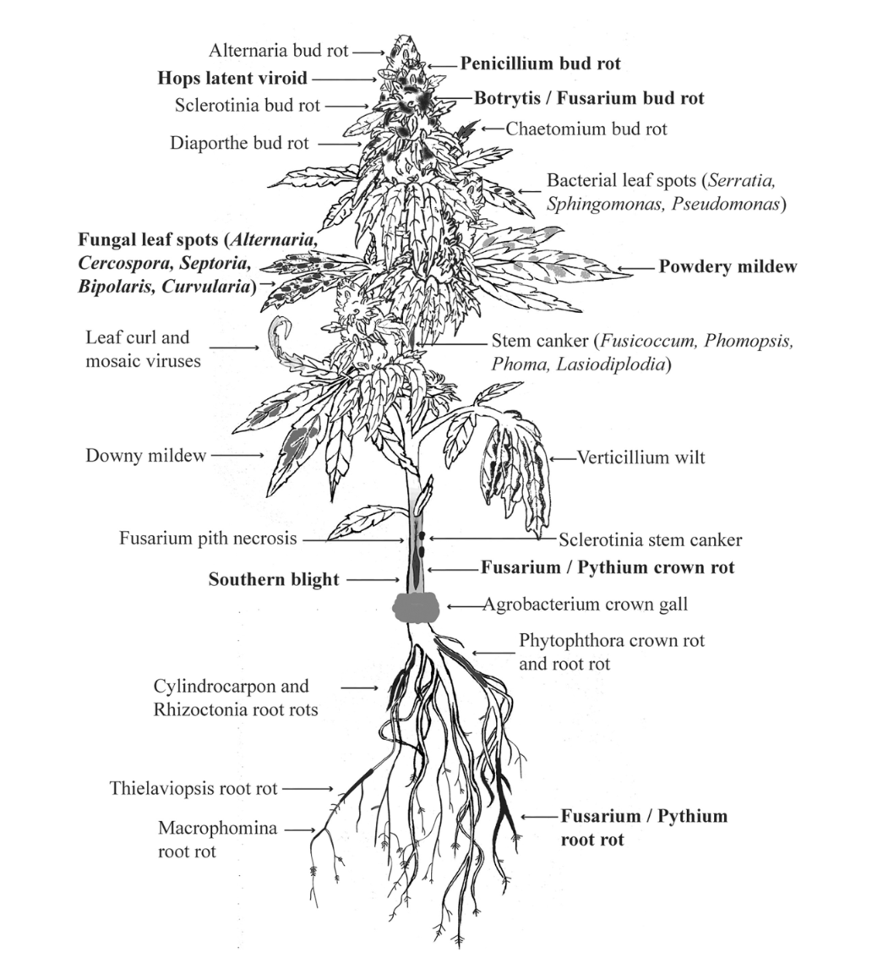
Fig. 8.4 Bacterial and fungal endophytes that have been isolated from specific tissues of Cannabis sativa. The populations of endophytes identified within Cannabis tissue varied greatly with geographical origin of the samples (Punja,, 2021).

Because it is likely that the majority of Cannabis endophytes are horizontally transmitted they must be acquired from ambient inocula during an individual plant's lifetime. Therefore the local inocula will determine the endophyte population within a Cannabis plant. It is likely that when spraying compost tea and other forms of fungal inoculation, some of these organisms may be able to act as endophytes and enter into the plant tissue (through a wound, stomata, or via an appressorium).
With this fact in mind, the ecology of Cannabis endophytes among cultivated plants is potentially complicated by the illicit nature of the crop, at least historically. In regions with long and continuous histories of either stable populations of wild Cannabis or relatively large-scale cultivation as a crop, Cannabis-specialized endophytes may develop and persist. Populations of endophytes identified within Cannabis tissue vary greatly depending on the geographical origin of the plants sampled (Taghinasab and Jabaji 2020). Mutually beneficial symbiosis are favored when the host plant and fungal partner co-evolve over generations under conditions which favor their partnership. Conditions must improve the fitness (i.e. the reproductive ability) of both the host and the endophyte to be evolutionarily adaptive. If this continues to an evolutionary extreme, the organisms may even become obligatory partners, at least under the given conditions.
Some endophytes of Cannabis are able to pass from the parent plant to its offspring. They may do so either by surviving within the body of the seed, or on the seed surface. Bacterial endophytes involved in the rhizophagy cycle are known to pass within the plant body of embryos within seed as well (Verma and White 2019). If it is passed on the surface it must persist throughout seed dormancy, waiting to infect the newly germinating seedling as it emerges. Microorganisms harbored on the seed surface are susceptible to treatments (bleach, Trichoderma) prior to germination. Such treatments can reduce seedling losses to seed batches from parent plants infected with pathogens, particularly Botrytis cinerea. Other treatment options are heat treating the seeds or using systemic fungicides for internal transmission of antifungal compounds.

Table 2. Endophytes of Cannabis reported in the literature.

Aspergillus niger | Pathogen antagonist
Alternaria alternata | Pathogen antagonist
Paecilomyces lilacinus | Pathogen antagonist
Penicillium copticola | Pathogen antagonist
Aureobasidium pullans | Pathogen antagonist

Table 3. Endophytic fungi known to be isolated from Cannabis to date.

Genus | Specific epithet
Penicillium | P. copticola
Aspergillus | - versicolor
Chaetomium | C. globosum
Paecilomyces | P. afflilaecium
a= Cite sources for each; b;c;d (Kusare et al. 2013)

Characteristics of Mutualistic Endophytes
The nature of the host-endophyte relationship is not only dependent on the species involved, but a range of abiotic and biotic factors (Partida-Martínez and Heil, 2011). For instance, an endophyte that enhances host fitness by reducing predation or pathogen damage may become a net cost to the host in the absence of such stressors. For the moment we will only focus on endophytes that are mutualistic, in that they benefit the fitness of their host plant in some manner across a wide range of conditions.

Pathogen Protection

Beneficial endophytes may act to protect their host from pathogens by a variety of mechanisms. A few examples include modulating their host’s immune system, promoting host plant growth, production of secondary metabolites with various activities, occupation of a pathogen’s niche, or direct physical antagonism of a pathogen (Gao et al., 2010).
Endophytes also may benefit their host in unexpected and indirect ways; Lehtonen et al., (2006) showed reduced virus infection among endophyte infected plants due to reduced herbivory by the virus’s aphid vector. It is likely that Cannabis infected with mutualistic endophytic fungi will have superior disease resistance traits compared to uninfected crops. Effective endophyte applications have the potential to improve the health of crops while simultaneously decreasing the need of synthetic pesticides.

Table 3. Mechanism and mode of action induced by endophytic partners.
Mechanism | Mode of Action
Induced resistance | Plant Immune response is activated (PTI and ETI)
Competition | Physical occupation of niche and differential resource acquisition
Antibiosis | Negative interaction of one species to another, usually in response to excreted metabolic substances
Hyperparasitism | Pathogenic organism is parasitized directly
Plant growth promotion | Improved resistance may result from general growth promotion. Endophytes may increase growth by the production of plant hormones and improved nutrition (siderophore production, N-fixation, ect.)

For a fungus to persist as an endophyte within a plant host’s body, it must necessarily have at least some antagonistic abilities in order to evade host immune response and persist within its tissues (Schulz and Boyle, 2005). Plants recognize the presence of invaders via microbial, pathogen, and/or damage-associated molecular pattern-triggered immunity and effector triggered immunity (Jones and Dangl 2006). When the plant senses invaders, it triggers induced resistance and/or systemic acquired resistance, which are both whole-plant immune responses. Endophytes capable of persisting in planta only trigger induced resistance, a milder response. Endophyte and host actions must remain balanced for successful endophyte infection (Schulz et al. 1999).
Endophytes may benefit the host plant in ways beyond induced resistance. Plant growth promotion may result from endophyte-induced upregulation of host production or direct synthesis of secondary metabolites otherwise absent in the host plant; increasing host nutrient acquisition and growth by producing chelating compounds, enzymes and phytohormones or atmospheric nitrogen fixation; or by improving oxidative stress tolerance of the host (Mucciarelli et al., 2007; Yuan et al, 2010; White and Torres, 2010, Triplett 1996, Kahn et al. 2015, Verma et al. 2011, You et al. 2012).
Physical exclusion of pathogens from a host plant by endophytic species also occurs via direct competition for and occupation of the same habitat (Gao et al., 2010). Research has confirmed extensive niche overlap among endophytes and pathogens of the same plant species (Blumenstein et al, 2015). Endophytes that come into direct physical contact with a pathogen of their host may also act directly to antagonize its competitor through chemical defenses or direct hyperparasitic attack. Trichoderma species for instance, which commonly occur as endophytes, act as hyperparasites; they are capable of coiling around and directly lysing the hyphae of other fungi.

Pest Protection

Clavicipitaceous endophytes have a proven history of usage in turf grass as a means to reduce insect herbivory and improve stress tolerance (Clay, 1991). Endophytes have also shown utility in woody plants for reducing herbivory (Miller et al., 2008; Wilson and Carroll, 1997).

Improved Product Quality or Potency
Endophytes may alter the phenotype of their host in a number of ways beyond pest protection and growth promotion. Of the most potential interest to Cannabis farmers is the prospect of endophytes to increase terpene or cannabinoid content. Endophytes have been shown to greatly increase terpene content in planta among mint plants (Mucciarelli et al., 2007). No research specific to Cannabis has yet been published, although several companies are commercializing products that make such claims.
Endophytic alteration of terpene expression could prove to be a valuable tool in Cannabis agriculture. Endophytes may affect cannabinoid production in similar fashion. This is an area in need of research and with high potential for exploitation by farmers. Some cannabinoids identified in Cannabis for which no synthesis genes are known may actually be microbially modified in origin (Robertson et al. 1975). The production of novel cannabinoids by the endophytic and post harvest microbiome may alter the pharmacological activity of the flower.
Manipulation of endophytes may improve product quality in another indirect way: by reducing the occurrence of human pathogenic and mycotoxin producing fungi among Cannabis destined for human consumption. It has been shown that known pathogenic fungi, such as Aspergillus niger and Cryptococcus species, and mycotoxin producing fungi, including Aspergillus flavus, Penicillium citrinum and P. commune are potentially common in Cannabis from American dispensaries (McKernan et al. 2015). At least some of the species that pose dangers to humans are likely normal, probably mutualistic, fungal epiphytes and endophytes of Cannabis.
Applying alternative microbes capable of fulfilling the symbiotic role of such fungi may be a viable option for excluding completely or vastly reducing the population of undesirable fungi without the use of chemical fungicides. Regulators should keep this scenario in mind when developing regulation for measuring fungal contaminants in agricultural products. Total yeast and mold counts that fail to differentiate harmless microbes from the dangerous human pathogens and mycotoxin producing fungi may prevent farmers growing under such regulations from applying beneficial inocula. Techniques able to differentiate among microbes, in order to identify those that pose danger to humans, such as molecular techniques, are preferable for ensuring the safety of consumable Cannabis.
Current Applications of Endophytes Among Cannabis Cultivation

Some currently available products contain entomopathogenic species that may live endophytically across a broad range of host plant species, likely including Cannabis. Beauveria bassiana, Isaria fumosorosea, Lecanicillium and Metarhizium spp. are all commercially available fungi that are bioinsecticides. Trichoderma sp. and Clonostachys rosea f. Rosea (Gliocladium catenulatum) containing products may be similarly applied as a persistent, endophytic biofungicide. Both aerial and root portions of the plant may benefit from endophyte application. While these are not marketed for foliar application, doing so may inoculate plants with persistent endophytic infections of these beneficial biopesticides (though may be a violation of their approved use). In some cases root inoculations may also form systemic infections.
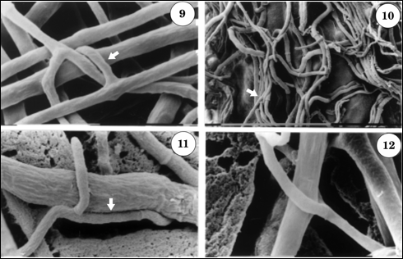
Fig. 8.5 Trichoderma hazarium parasitizing the mycelium of Fusarium culmorum. The arrows are indicating the T. hazarium parasite producing ‘hooks’ to wrap around the fungal pathogen. (Pisi et al. 2001).

While not the focus of this book, there are also prokaryotic species that may act in the same fashion; various Bacillus species are readily available commercially and will serve this purpose. Frequently, these species also benefit the plant when residing as endophytes by improving host immune response or promoting growth in myriad ways (Santoyo et al 2016). Kandel et al. has shown that naturally occurring bacterial endophytes of Poplar trees in Washington state may be introduced with positive effect into crop species, including maize, tomato, squash and pepper (2017). One way some bacterial endophytes may increase plant growth, in which fungi probably cannot, is the fixation of atmospheric nitrogen (James 2000).

Table 4. Commercially available products with activity as endophytic biofungicides or biopesticedes when applied as a foliar spray.

Fungal endophytes | Species | Commercial formulations | Target effect
 | Gliocladium virens | Soil guard | Damping off
 | Clonostachys rosea f. Rosea (syn Gliocladium catenulatum | Primastop | Botrytis, Verticillium, Alternaria, Damping off, Broad spectrum fungicide
 | Beauveria bassiana | Mycotrol | Aphids, thrips, whitefly
 | Trichoderma harzianum | RootShield | Damping off
Bacterial endophytes | Streptomyces griseoviridis | Mycostop | Pythium, Alternaria, Botrytis
 | Streptomyces lydicus | Actinovate | Fungal diseases
 | Bacillus thurengensis var isrealiensis | Gnatrol | Mosquitoes, fungus gnats

Endophytes as Commensals (Latent Decomposers or Latent Pathogens?)
Some endophytes, depending on the circumstances, may not cause any overall benefit or harm to the host organism. In this case the endophyte is in a commensal relationship with the plant, where the endophyte is receiving some benefit while causing no effect to the host. This functional delineation is quite narrow, as any endophyte is going to trigger a physiological interaction and is therefore unlikely to cause no cost or benefit to the host. However, there are some groups of endophytes for which this grouping is useful, even if somewhat artificial. These include endophytes that may be acting as latent decomposers.
The rapidity with which recently dead plant tissues are colonized has lead to the suggestion that some saprophytic fungi may take up residence in living plants, then behave as dormant or innocuous commensal endophytes waiting to be triggered by a change in the environment, possibly reduced moisture content of dead and dying wood. In this manner it may be possible for saprobic fungi to make claim to their food resource before it is ready to be consumed. This would give a head start over competition saprobes attempting to move in once the host material has died. Some of these putative commensal saprobes may lean towards parasitic roles, residing in symptomless tissue as latent pathogens lying in wait.

In Defense of Endophytes in Agriculture
As should happen with any new technology, the manipulation of endophytes for agronomic reasons has been questioned (McCoy, 2016). Some of the concerns about the application of endophytes are legitimate, as will be discussed. These concerns, however, do not preclude responsible integration of these organisms in Cannabis agriculture or agriculture generally. The crux of the concern lies with the potential for an endophyte to (1) cause disease in non-target organisms and (2) for the alteration of the general ecology of endophytes.
The first concern, non-target effects, must be considered during product development for any biological control agent. Releasing a biological agent into an ecosystem from which it is not native poses inherent, undeniable risks. Useful biocontrol agents, by their nature, are able to cause disease or otherwise reduce the fitness in target organisms. Therefore the potential for them to do so in non-target organisms is a real possibility. Oftentimes the most successful biocontrol agents are organisms that are not native to the particular region in which they are being applied (Cook and Baker, 1983).
A technique that can be utilized to reduce the potential for such risk is to ‘mine’ the local endophyte population for applicable biocontrol agents. By collecting and testing endophytes native to the region or ecosystem where they will be applied, farmers may eliminate much of the risk associated with the transportation and introduction of exotic species which may result in potentially devastating unintended side effects. This can easily be done at any Cannabis farm with modest lab equipment and would be a simple way to increase the population of nonpathogenic fungi. In this instance, farmers may even be protecting local biodiversity as refuges of natural endophytes are lost to development in the area (if true this may serve as a benefit rather than a risk, relating to concern #2).
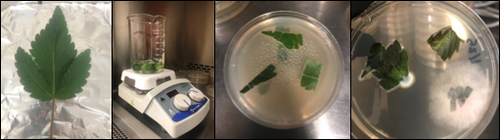
Fig. 8.9 Mining for endophytes by collecting plant tissue, surface sterilizing healthy leaves, plating the plant material on a nutrient agar (potato dextrose agar with antibacterials is commonly used) and then isolating individual fungi that grow out.

The second concern, alterations of endophyte ecology, is more nuanced and difficult to evaluate for many reasons. Not least of which is our still incomplete descriptions and poor understanding of endophyte ecology. For many years most endophyte research was descriptive, simply listing species found to occur as endophytes among various host species. Such research has been crucial to elucidating the extent and nature of the niches exploited by endophytes and now show that many species are host restricted, while others are generalists capable of colonizing a wide range of host species (endophytes may also be tissue restricted or capable of colonizing all types of plant tissue). From this origin, researchers have also moved towards the investigation of ecological roles of endophytes and the physiological effects they can have on their hosts.
Endophyte ecology is dependent on host population dynamics and propagule dissemination. All management options will have ripple effects among all species within a managed area. Therefore, literally any land use activity by humans will affect endophyte ecology by affecting habitat and host availability (endophyte populations are similarly affected by natural disturbances and ecosystem succession in both human-managed regions and areas that remain wild). Humans also affect endophyte populations broadly and indirectly; air pollution is known to negatively affect horizontal endophyte acquisition (Helander et al, 2011). Endophyte application among crops may be increasingly necessary in order to offset such alterations among natural endophyte population dynamics.
Many potential endophyte species recommended earlier in this book are already used extensively in agriculture. Most of these are races of species which are cosmopolitan in nature. No known negative environmental effects have occurred due to the use of these species. While the absence of evidence is not evidence of absence, environmental effects and non-target effects from these commonly occurring organisms are likely very low or nonexistent when applied to agricultural crops. There is a possibility that the application of large amounts of inocula for these species may affect the endophyte population of the nearby flora. If it is found that endophyte application does affect the native endophyte ecology and possibly other ecological components, we must still balance this against the environmental effects of status quo- conventional agriculture, so that we may strive for the best possible outcomes.
Improving desirable species by pairing them with beneficial endophytes has the potential to reduce the need for pesticide, insecticide, and even nutrient applications, as well as offering effective alternatives to genetic modification as the only solution for some of the intransient problems facing the future of agriculture. In this way we may be able to confer beneficial traits to plants without the alternative risks of inserting foreign genetic material into their genome, which may escape the GMO population and taint the species or its wild relatives more broadly (Rodriguez et al. 2008).
To not use any endophytes in agriculture due to a vague fear of causing unintended consequences, however well intentioned, is an unnecessary crippling of a potentially valuable tool for reducing environmental damages caused by agricultural practices. Regardless, it remains desirable to reduce or eliminate unintended effects. Some may apply a similar utilitarian sentiment to genetic modification or CRISPR for use in agriculture, though that is a debate for a different day in a different forum. Regardless where you stand on those issues, endophyte technology may be used by all sectors of agriculture, including certified organic production methods where genetically modified crops are banned.

